Threat Hunting On Security Onion

Scenario 10 — Threat Hunting Challenge

Objective
Proactively hunt for indicators of compromise within Security Onion by identifying:
- Unusual User Agents
- Connections to Newly Registered Domains (NRDs)

Investigation & Findings
1. Unusual User Agents
Detected multiple Suricata alerts pointing to suspicious HTTP

Activity:
ET HUNTING GENERIC SUSPICIOUS POST to Dotted Quad with Fake Browser

Description: Indicates fake or manually generated HTTP requests attempting data exfiltration or command-and-control (C2) communication.
ET SCAN Zmap User-Agent (Inbound)

Description: Signifies scanning behavior from a known mass scanner, suggesting reconnaissance attempts.

Interpretation: These patterns show evidence of active probing or custom C2 traffic rather than legitimate browser communication.



2. Connections to Newly Registered Domains (NRDs)
From Suricata DNS logs and HTTP alerts , the following patterns were observed:

ET INFO External IP Lookup (api.ipify.org)

Description: Indicates malware behavior of querying external IPs to identify its public address.
DNS queries to low-reputation or uncommon domains that appeared recently in traffic logs.

Interpretation: Early-stage malware or phishing payloads often connect to newly registered domains for C2 registration or payload retrieval.
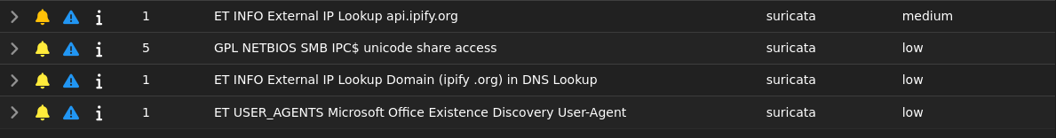

Correlation Summary

Combining Suricata and Zeek telemetry:
- The fake User-Agent activity and external IP lookups suggest beaconing behavior .
- NRD connections strengthen the hypothesis of compromised or beaconing hosts .

Conclusion
The threat hunting exercise successfully uncovered:
- Signs of potential C2 communication via custom user agents and SSL tunnels.
- Evidence of scanning and malicious domain interactions.
- Proficiency in correlating data across Zeek, Suricata, and Elastic for threat detection.

Tools Used:
Security Onion, Zeek, Suricata, Kibana
Tags:
#CyberSecurity #ThreatDetection #threathunting #WebSecurity #SecurityOnion #Zeek #Suricata #BlueTeam

